13.3 Editors - Video Sequence Editor - Sidebar
Introduction 1
Right Click menus 1

Introduction

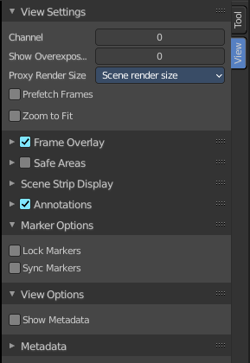
The Video Sequence Editor is made of several areas. And it is made of two editor types. Preview and Sequence.

At the right side you will find the sidebar with further options and settings for the VSE and its tools.

Right Click menus

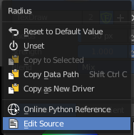
You will open the usual right click menus when clicking with the right mouse at elements in the sidebar. Its content is in big parts self explaining.

The right click menus are explained in the chapter 6 Editors Introduction.

